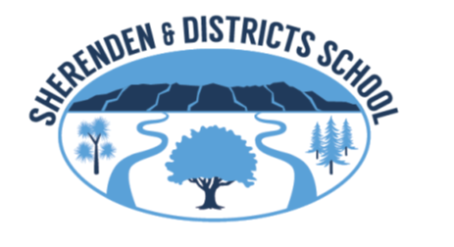

Dependent-Rookie Learner

RESPECTFUL
- I am learning when to be quiet and when to talk
- I am learning to listen and follow instructions
- I am learning to work with others
- I am learning to respect all equipment

ORGANISATION
- I am learning what to do when the bell rings
- I need help to get my pens, pencils and books ready for learning
- I am learning to put my belongings in the correct place

ASPIRATIONAL
- I try to copy what the teachers shows me
- I need help to find my SMART goals
- I am learning to stay on the set task
- I am learning to do my homework

RESILIENCE
- I am learning that its okay to make mistakes
- I am learning to talk about how I am feeling

Guided-Orchestrated Learner

RESPECTFUL
- I need some reminders of when to be quiet and when to talk
- Sometimes I listen and do what I am supposed to do
- I am usually a good team member
- I respect all equipment at all times
ORGANISATION
- I am usually punctual and ready to learn
- I go to the toilet and have a drink of water during break times
- I usually have the correct equipment for my learning
- I keep my belongings in the correct place
ASPIRATIONAL
- I can listen to feedback and make sense of it
- I know where to find my goals
- I try to stay on task and complete my learning within the set time frame
- I listen when reminded to stay on task and get most of my learning done within the set time frame
- My homework is usually completed and returned to school
RESILIENCE
- I know its okay to make mistakes
- When learning gets hard I need encouragement from others to keep going
- I try to explain my learning

Independent-Aspiring Learner
RESPECTFUL
- I often know the appropriate time to talk and when to be quiet
- I often listen and pay attention
- I am a good team member and I am learning to lead
- I respect all equipment at all times

ORGANISATION
- I am always punctual and ready to learn.
- I always have the correct equipment for my learning

ASPIRATIONAL
- I listen to feedback and know how to use it to help me in my learning
- I sometimes self assess
- I often know what I am learning and why
- I am beginning to articulate my learning
- I have SMART learning goals
- I am often on task and have my learning completed within the set time frame including my homework
RESILIENCE
- I am learning to learn from my mistakes and from mistakes of others
- When learning gets difficult I persevere with my learning
- I can speak clearly about my learning

Self Agent-Role Model Learner
RESPECTFUL
- I know the appropriate time to talk and when to be quiet
- I consistently listen and pay attention
- I am a good leader and a good team member
- I respect all equipment at all times

ORGANISATION
- I am always punctual and ready to learn.
- I always have the correct equipment for my learning

ASPIRATIONAL
- I seek feedback from the teacher and peers because it helps me to improve in my learning.
- I regularly self-assess
- I know what I am learning and why
- I can articulate my learning.
- I have SMART learning goals, can provide evidence of them and am aware of my next steps.
- I am always on task and have my learning completed within the set time frame including my homework
- I encourage others to make good choices and to do their best
RESILIENCE
- I learn from my mistakes
- When learning gets difficult I have various ways to help my learning
- I can speak clearly and explain my learning so I am understood by others

